**HR Data Analytics**

**Purpose:**Analyze human resource data to identify   
 1. Overtime  
 2. Marital Status  
 3. Job Role  
 4.Gender  
 5. Education Field          
 6. Department  
 7. Business Travel  
 8. Relation between Overtime and Age  
 9. Total Working Year  
 10. Education Level  
 11. Number of Companies Worked  
 12. Distance from Home

**Description:** In this project, you will dive into a large dataset to extract valuable insights. You will create visualizations to present your findings effectively. This project showcases your ability to manipulate and derive insights from large datasets, enabling you to make data-driven recommendations for optimizing strategies.

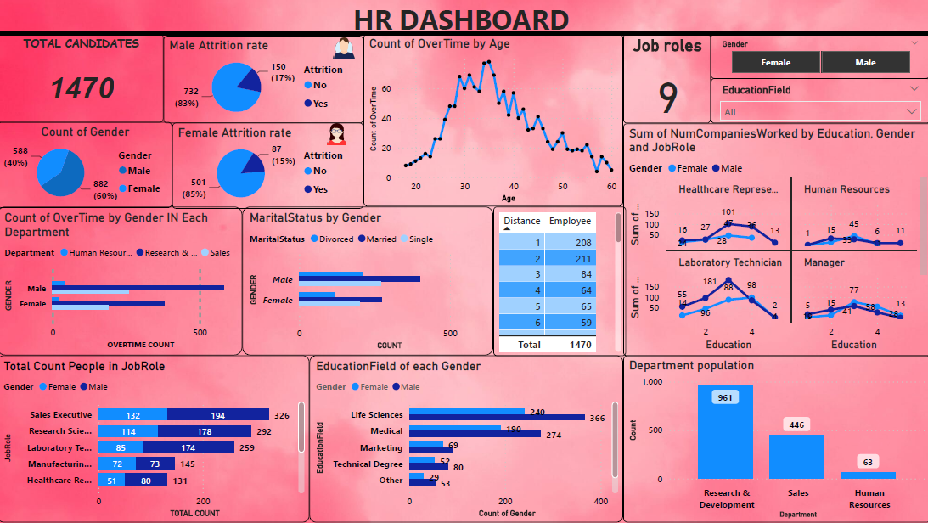

**Analysis:**  
1. There are more Male applicants than male by 294.  
2. Attrition rate of males is higher than females.  
3. Overtime is majorly done by people who are in the Age grp of 34-35.  
4. Overtime is majorly done by males of research and development department and is least likely to be done by   
 females of human resource department.  
5. Talking about marital status ,mostly men’s are married.  
6. Distance-employee table depicts that are distance grows the number of employees decrease.  
7. Highest literacy rate is observed among people working as sales executive.  
 Majorly people having education level 3 are more likely to be worked in more than 1 company.  
 People with education level 5 are more likely to work at a specific organization without frequent change.  
8. The most populated department is Research and development.  
9. There are total of 9 job roles where mostly applicants are there in sales executive with a total count of 326.  
10. Major field where people are working is Life Sciences.  
11. Majority company should focus on Research department to reduce the overcrowding in that area in future.  
  
Project Link: <https://github.com/ankit5163/HR_data_analysis_MeriSkill>